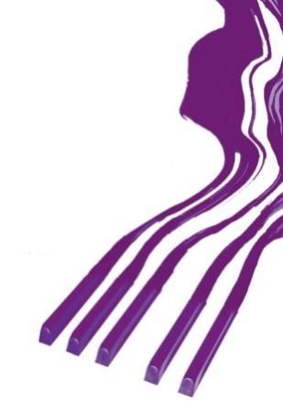
REZULTATI KLAVIR SOLO / RESULTS PIANO SOLO

DRUGA KATEGORIJA / SECOND CATEGORY

Takmičar/Competitor | Datum rođenja/Date of birth | Ilia Tchernaev | Olga Borzenko | Dragomir Bratić | Irina  Mints | Ocena/Points | Nagrada/  Award
1. Zhongshu Chen,  Prof. Teguh Sukaryo | 3. 8. 2011. | 100 | 100 | 100 | 100 | 100 | Laureat
2. Yordan Popov,  Prof. Elena Taseva | 4. 8. 2010. | 93 | 97 | 93 | 90 | 93,25 | I-2
3. Teodor Proshev,  Prof. Milan Jankuloski | 16. 9. 2010. | 88 | 95 | 98 | 91 | 93 | I-3
4. Dora Šarić,  Prof. Tajana Lazović | 24. 2. 2010. | 89 | 92 | 98 | 92 | 92,75 | I-4
5. Sara Sabadoš,  Prof. Olivera Sekulić | 18. 5. 2010. | 83 | 92 | 95 | 92 | 90,50 | I-5
6. Sara Pavlović,  Prof. Milena Pejić | 11. 10. 2010. | 85 | 90 | 96 | 90 | 90,25 | I-6
7. Dunja Marković,  Prof. Sanja Suton Stanković | 20. 5. 2010. | 84 | 92 | 95 | 85 | 89 | II-1
8. Nikola Pavlović,  Prof. Milena Pejić | 11. 10. 2010 | 78 | 88 | 91 | 83 | 85 | II-2
9. Ema Horja,  Private prof. Judith Widrig | 9. 6. 2010. | 77 | 84 | 86 | 84 | 82,75 | II-3
10. András Gyurákovics,  Prof. Jácinta Farkas | 2. 11. 2010. | 75 | 85 | 87 | 83 | 82,50 | II-4
11. Oyundari Amgalan,  Prof. Erdenechimeg Uranbileg | 10. 6. 2010. | 76 | 78 | 80 | 70 | 76 | III-1

Memorial „Sanja Pavlovic“-piano competition
March, 2022, Aleksinac, Serbia

