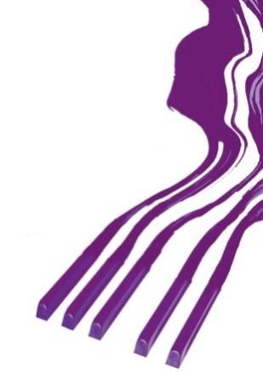
REZULTATI KLAVIR SOLO / RESULTS PIANO SOLO

SEDMA KATEGORIJA / SEVENTH CATEGORY

Takmičar/Competitor | Datum rođenja/Date of birth | Ilia Tchernaev | Olga Borzenko | Dragomir Bratić | Irina  Mints | Ocena/Points | Nagrada/  Award
1. Ana-Maria Uzunova,  Prof. Mariana Shikova | 26. 5. 2004. | 100 | 100 | 100 | 99 | 99,75 | I-1
2. Lucija Matijević,  Prof. Ivanka Kordić | 30. 11. 2003. | 100 | 98 | 100 | 96 | 98,50 | I-2
3. Maciuca Miruna Mihaela,  Prof. Zamfirescu Mihaela | 7. 11. 2005. | 95 | 99 | 96 | 95 | 96,25 | I-3
4. Tatyana Dokeva,  Prof. Alexander Botusharov | 30. 3. 2004. | 88 | 90 | 95 | 88 | 90,25 | I-4

Memorial „Sanja Pavlovic“-piano competition
March, 2022, Aleksinac, Serbia

